ISO/IEC 25010:2023
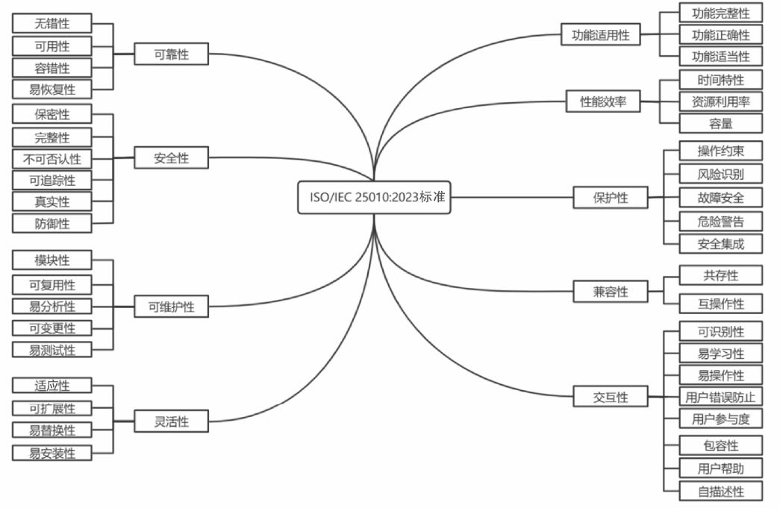
图1 ISO/IEC 25010:2023标准中软件质量特性及其子特性的关系
1．功能适用性
功能适用性（Functional Suitability）是指软件在一定条件下须满足一系列明确及 隐含的需求，其又细化为以下三项子特性。
Note 1 to entry: Functional suitability is concerned with whether the functions meet not only stated and implied needs, but also the functional specification.
（1）功能完整性（Functional Completeness）：软件提供的一套功能覆盖所有特 定任务和预期用户目标的能力。
（2）功能正确性（Functional Correctness）：当预期用户使用该软件时，软件提 供正确结果的能力。
Note 1 to entry: Precision is one of the attributes of correctness.
EXAMPLE: In case of the products requiring high precision such as scientific software, the product can provide precise results with the needed degree as well as accurate results.
（3）功能适当性（Functional Appropriateness）：软件提供功能以促进特定任务 完成的能力。
EXAMPLE: A product provides the necessary and sufficient steps to complete a task, excluding any unnecessary steps.
Note 1 to entry: Functional appropriateness corresponds to suitability for the task in ISO 9241-110.

2．性能效率
性能效率（Performance Efficiency）是指软件在特定条件下能够在规定的时间、吞吐量、参数范围 内执行其功能，且高效利用资源的能力，包括以下三项子特性。
Note 1 to entry: Resources can be CPU, memory, storage, and network devices.
Note 2 to entry: Resources can include other software products, the software and hardware configuration of the system, energy, and materials (e.g. print paper, storage media).
（1）时间特性（Time Behaviour）：软件在特定条件下执行其指定功能并满足响应时间和吞吐量要 求的能力。
（2）资源利用率（Resource Utilization）：软件在特定条件下执行其功能时使用资源不超过指定 数量。
（3）容量（Capacity）：软件能够处理的最大负载或数据量。
Note 1 to entry: Parameters can include the number of items that can be stored, the number of concurrent users, the communication bandwidth, the throughput of transactions, and the size of a database.

3．兼容性
兼容性（Compatibility）是指软件在执行所需功能时，与其他软件或组件共享硬件或软件环境、交 互信息的能力，包括以下两项子特性。
（1）共存性（Co-existence）：软件在与其他软件共享环境与资源时执行所需的功能，不对其他任何 产品产生负面影响的能力。
（2）互操作性（Interoperability）：在两个或多个软件或组件间交换信息与使用已交换信息的能力。
Note 1 to entry: Information is meaningful data; and information exchange includes transformation of data for exchange.

4．交互性
交互性（Interaction Capability）是指软件通过用户接口与指定用户交互，来实现用户和系统之间的 信息交换，并完成预期任务的能力，包含以下八项子特性。
Note 1 to entry: Interaction capability in the product quality model and its subcharacteristics focus on a set of attributes that enable interaction by users (or operators) to complete specific tasks in a variety of contexts of use. On the other hand, usability as defined in the quality-in-use model (ISo/IEC 25019) comprehensively focuses on outcomes of use to determine whether tasks are achieved by users with effectiveness, efficiency and satisfaction in a specific context of use.
Note 2 to entry: Interaction capability is a prerequisite for usability.
Note 3 to entry: Interaction itself is defined in ISO TR 25060 as “exchange of information between a user and an interactive system via the user interface".
（1）可识别性（Appropriateness Recognizability）：被用户认识到符合他们需求的能力。
Note 1 to entry: Appropriateness recognizability depends on the ability to recognize the appropriateness of the product functions from initial impressions of the product or system and/or any associated documentation.
Note 2 to entry: The information can be provided by the product to assist users in making decisions about the adoption, acquisition, or use of products prior to the start of full-scale use, through demonstrations, tutorials, documentation or,for a website, the information on the home page.
（2）易学习性（Learnability）：让特定用户不用花费太多时间就能学会使用特定产品功能的能力。
（3）易操作性（Operability）：软件拥有的功能和属性让其操作和控制起来很轻松的能力。
Note 1 to entry: Operability is related to controllability, user error robustness and conformity with user expectations as defined in ISO 9241-110. It is also related to the effectiveness and efficiency of physical interface devices (e.g. mouse, touch pen).
（4）用户错误防止（User Error Protection）：软件阻止操作错误发生的能力。
（5）用户参与度（User Engagement）：软件以吸引人和激励人的方式展现自己的功能和信息，鼓励 用户持续进行交互的能力。
Note 1 to entry: This refers to properties of the product that increase the pleasure and satisfaction of the user, such as harmonious colour, intuitive user interface and friendly voice guidance.
（6）包容性（Inclusivity）：软件被各种背景的人使用的能力。
Note 1 to entry: Backgrounds include (and are notlimited to) people of various ages, abilities, cultures, ethnicities, languages, genders, economic situations, education, geographical locations and life situations.
（7）用户帮助（User Assistance）：在特定的使用场景下，让有各种各样特征和能力的人使用，以 达成指定目标的能力。
Note 1 to entry:The range ofcapabilitiesincludes language differences and disabilities associatedwith age,sight, hearing, use of hands, arms and legs, etc.
Note 2 to entry: A set of specific rules and methods for software accessibility can be applied to ensure "user assistance"” in this document and in ISO/IEC 25019.
EXAMPLEA system that can interact with users using multiple input/output methods, such as voice, gaze, and touch, in addition to visual display, in order to accommodate differences in vision, hearing, and body parts that can be moved, or changes in these areas.
Note 3 to entry: Inconveniences or less efectiveness for users caused by differences or changes in their actual contexts of use beyond those initially specified in the requirements can be resolved by repeating the quality improvement cycle to find and resolve problems through iterative evaluation and requirements definition from this quality characteristic perspective.
Such differences or changes in the context of use can include,for example, the following cases:
- when using the system while driving a car or flying in an airplane;
- when using the system interactively for emergency within short-time use and small screen view due to an accident or a disaster;
- when a user is a beginner or is changing own task goal of use, usage, or skilland knowledge;
- when a user having different physical capabilities due to the type of injury or illness, or changes in time due to healing or progression.
Also, other quality. (sub)characteristics, typically such as adaptability or flexibility , can be collaboratively applied to improve user assistance and interaction capability.
（8）自描述性（Self-descriptiveness）：在用户需要的地方展示适当的信息，令软件功能和使用方法 对用户显而易见，而不需要用户过度地与产品交互或依赖其他资源的能力。
Note 1 to entry: Other resources include user documentation, help desks, other users and other sources of assistance.
EXAMPLE Instructions for user operation are divided and displayed or talked through step-by-step interactively at the helpful timing of operation, in order to help users understand easily what is going on with the system/software and to prevent users from becoming confused by receiving too many instructions at once.
5．可靠性
可靠性（Reliability）是指软件在一定条件下连续一段时间执行特定功能而不发生中断和故障的能 力，包括以下四项子特性。
Note 1 to entry: Wear does not occur in software. Limitations in reliability are due to results from faults in requirements, design and implementation, or from contextual changes.
Note 2 to entry: Dependability is often used as a synonym for reliability. However, dependability has a larger scope in that itincludes security, performance eficiency.
（1）无错性（Faultlessness）：软件在正常操作下执行特定功能不产生故障的能力。
Note 1 to entry: The concept of faultlessness can also be applied to other quality characteristics to indicate the degree to which they meet required needs under normal operation.
（2）可用性（Availability）：软件在使用时可操作和可访问的能力。
Note 1 to entry: Externally, availability can be assessed by the proportion of total time during which the system, product or component is in an up state. Availability is therefore a combination of faultlessness (which governs the frequency of failure), fault tolerance and recoverability (which governs the length of down time following each failure).
Note 2 to entry: Failover or duplication of systems can be applied to support availability.
（3）容错性（Fault Tolerance）：软件在有故障或未使用指定接口的情况下，依然按预期运行的能力。
（4）易恢复性（Recoverability）：在发生一次中断或故障后，恢复被直接影响的数据，并重新建立 期望的系统状态的能力。
Note 1 to entry: The length of the unavailable period following a failure, during which a product is not available at the same level of use as before the failure, is determined by its recoverability. However, the recoverability of a product depends on the recoverability of the computer system on which the product operates or a subset of its functions.
6．安全性
安全性（Security）是指软件保护信息和数据，让个人或其他软件拥有的数据的访问程度符合其授 权的类型和等级，同时抵御来自恶意攻击者的入侵的能力，包括以下六项子特性。
Note 1 to entry: As wel as data stored in or by a product or system, security also applies to data in transmission.
（1）保密性（Confidentiality）：保证数据只被有访问授权的请求获取的能力。
（2）完整性（Integrity）：确保其系统状态和数据免受未经授权的修改或删除的能力，无论是由于 恶意行为还是计算机错误。
（3）不可否认性（Non-repudiation）：在某种行为或事件发生后，确保该行为或事件不被否认的能力。
（4）可追踪性（Accountability）：使一个实体的行为被唯一追溯到该实体的能力。
（5）真实性（Authenticity）：证明一个主体或资源的身份与其所声称的身份一致的能力。
（6）防御性（Resistance）：当软件遭受恶意攻击时保证软件正常运行的能力。
Note 1 to entry: A malicious attack can include a denial of service attack, a ransomware attack, or other malicious actions. Then, the following approaches can be applied to improve the capability of a product for the quality subcharacteristic:
- to continuously protect itself from well-known attacks by removing potential flaws or weaknesses of the product with the use of security tools such as a security weakness diagnostic tool, vulnerability scanner and static analysis tool;
- to minimize vulnerability of a product with secure software coding and/or by incorporating security enhancement functions or mechanisms;
- to maintain product updates during its life time for security reasons.
7．可维护性
可维护性（Maintainability）是指软件被高效地修改的能力，包括以下五项子特性。
Note 1 to entry: Modifications can include corections, improvements or adaptation of the product to changes in environment, and in requirements and functional specifications. Modifications include those caried out by specialized support staff, and those carried out by business or operational staf,or end users.
Note 2 to entry: Maintainability includes installation of updates and upgrades.
Note 3 to entry: Maintainability can be interpreted as either an inherent capability of the product to facilitate maintenance activities, or the quality-in-use experienced by the maintainers for the goal of maintaining the product.
（1）模块性（Modularity）：软件由若干独立的组件构成，修改一个模块对其他模块的影响被降到最低。
Note 1 to entry: Modularity implies that the product is composed of discrete modules or components with cohesive content and minimal coupling to other modules or components.
（2）可复用性（Reusability）：软件的资产被其他软件复用的能力。
（3）易分析性（Analysability）：软件高效地评定自身的一个或多个部分发生预期变更所产生的影 响，以诊断故障的成因，进而识别出需要进行修改的部分的能力。
Note 1 to entry: Implementation can include providing mechanisms for the product to analyse its own faults and providing reports prior to a failure or other event.
（4）可变更性（Modifiability）：软件被高效地修改，且不引入新的缺陷或降低现有产品质量的 能力。
Note 1 to entry: Implementation includes coding, designing, documenting and verifying changes.
Note 2 to entry: Modularity and analysability can influence modifiability.
Note 3 to entry: Modifiability is a combination of changeability and stability.
（5）易测试性（Testability）：软件允许客观可行的测试被设计和执行，以确定需求是否达到要求的 能力。
8．灵活性
灵活性（Flexibility）是指软件适应其必要条件、使用环境、系统环境发生变化的能力，包括以下四项子特性。
Note 1 to entry: Flexibility to context of use should consider two distinguished aspects, i.e. technical and non-technical., The technical aspect is related with the execution environment of products, such as software, hardware and communication facility; and the non-technical aspect is related with the social environment, such as user and task, and the physical environment, such as climate and nature.
（1）适应性（Adaptability）：软件无须采用其他活动或手段就可适应不同环境的能力。
Note 1 to entry: Adaptations include those carried out by specialized support staff, and those carried out by business or operational staff, or end users.
Note 2 to entry: If the product is to be adapted by the end user, adaptability corresponds to suitability for individualization as defined in ISO 9241-110.
Note 3 to entry: Ineffectiveness or inefficiencies for users caused by differences or changes in their actual contexts of use beyond those initially specified in the requirements can be resolved by repeating the quality improvement cycle, in which evaluation and requirements definition are iterated from the perspective of this quality characteristic, and problems are discovered and solved.
Also, other quality subcharacteristics, typically such as inclusivity and user assistance, can be collaboratively applied to improve adaptability and flexibility (3.8).
Such differences or changes in the context of use can include, for example, the following cases:
- when using the system initially unintended circumstances, e.g. underwater or in outer space;
- when using the system in limited operation mode with less energy supplies or no communication networkconnectivity due to an accident or a disaster;
- when initially unintended types of users are involved or influenced.
（2）可扩展性（Scalability）：软件处理增长或缩减的工作负载，或调整容量应对变化能力。
（3）易替换性（Replaceability）：软件在相同的目标和环境下替代其他特定产品的能力。
Note 1 to entry: The replaceability ofa new version ofa software productis important to the user when upgrading
Note 2 to entry: Replaceability can include attributes of both installability and adaptability. The concept has been introduced as a subcharacteristic of its own because of its importance.
Note 3 to entry: Replaceability reduces lock-in risks, so that other software products can be used in place of the present one,for example by the use of standardized file formats.
（4）易安装性（Installability）：软件在特定环境下高效安装或卸载的能力。
Note 1 to entry: If the product is to be installed by an end user, installability can affect the resulting functional appropriateness and operability.
9．保护性
保护性（Safety）是指软件在规定条件下避免人身安全、健康、财产或环境遭受危害的能力，包括 以下五项子特性。
Note 1 to entry: In this document, safety is defined to describe capability of product to be able to avoid exposures which is not tolerable. Then, the definition is different from the other standards relating to safety that define safety as freedom from unacceptable risks.
（1）操作约束（Operational Constraint）：当遇到操作风险时，软件将其操作约束在安全的参数或状 态范围内的能力。
Note 1 to entry: Operational hazard is a hazardous situation, a circumstance in which people, property or the environment are exposed to an unacceptable risk during operation.
EXAMPLE 1 A constraint that prevents an airplane from entering a stall condition caused by environmental conditions or pilot error.
EXAMPLE 2A constraint that limits the amount of radiation released by a radiology device to a safe threshold regardless of the operator input.
（2）风险识别（Risk Identification）：软件识别出可能导致人身安全、财产、环境暴露在不可接受 风险下的一系列事件或操作的能力。
（3）故障安全（Fail Safe）：发生故障时，软件自动将自身调整到安全运行模式，或恢复到安全状 态的能力。
Note 1 to entry: When the fail safe quality subcharacteristic is applied to a complex system or software, it is often very difficult to determine which behaviour is safer. In such a case, functional safety concept can be used and then, hazard analysis and safety risk assessment can be conducted to derive safety goals and safety requirements to be achieved.
Note 2 to entry: The following approaches can be applied to improve the capability of a product for the quality subcharacteristic:
- to operate in a manner that eliminates or minimizes damage caused by a failure;
- to implement a mechanism to transfer control of a sufficient set of operations to continue safe performancewhen a failure occurs.
EXAMPLEA traffic light that reverts to blinking red in all directions when normal operation fails.
（4）危险警告（Hazard Warning）：软件向操作者或内部控制部门提供风险警告，使他们有足够的 时间采取行动以维持软件正常运行的能力。
EXAMPLE A pedestrian traffic light gives a warning sign, such as showing the remaining seconds, before reverting from green to yellow or red.
（5）安全集成（Safe Integration）：软件在整合一个或多个组件期间或之后保持其保护性的能力。

